Lab-20.1
Name: V.Sriram
2303A53009
Batch:46

Lab 20 – Security Testing: Identifying Vulnerabilities in AI- Generated Code

Task 1 – Input Validation Check Task:
Analyze an AI-generated Python login script for input validation vulnerabilities.
Instructions:
- Prompt AI to generate a simple username-password login program. • Review whether input sanitization and validation are implemented.
- Suggest secure improvements (e.g., using re for input validation). Expected Output:
- A secure version of the login script with proper input validation.

Prompt to AI:
"Generate a simple Python login program that takes a username and password from the user and checks if they match a hardcoded value." Code:
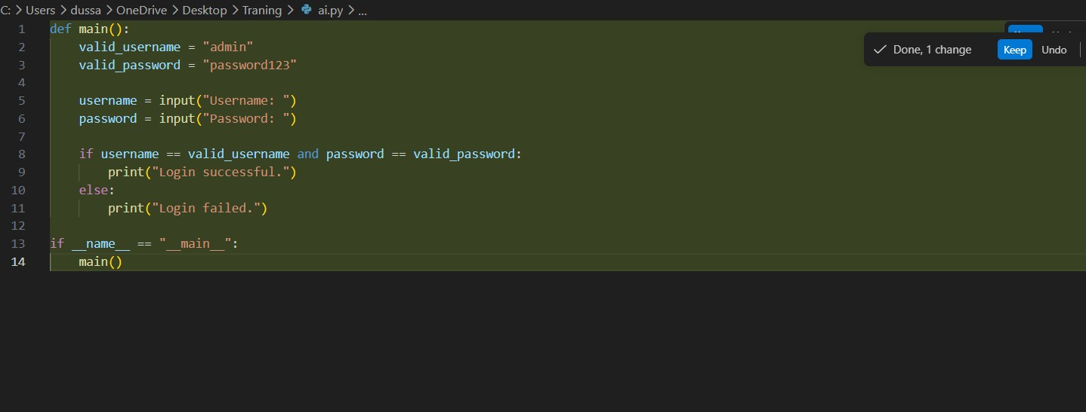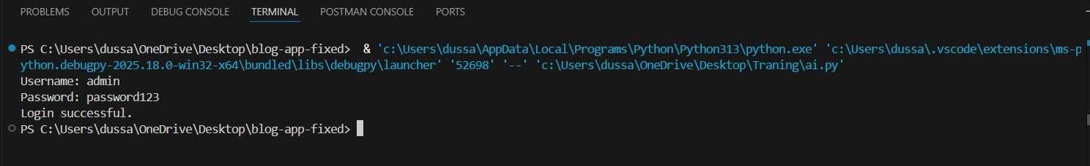
Explanation
- Vulnerability: Accepting raw input without checking length or type.
- The Risk: Buffer overflows or unexpected script execution.
- The Fix: Use Regex (re module) to allow only specific alphanumeric characters and set a strict length limit.
- Rule: Sanitizing input is the first line of defense.
Task 2 – SQL Injection Prevention Task:
Test an AI-generated script that performs SQL queries on a database.
Instructions:
- Ask AI to generate a Python script using SQLite/MySQL to fetch user details.
- Identify if the code is vulnerable to SQL injection (e.g., using string concatenation in queries).
- Refactor using parameterized queries (preparedstatements). Expected Output:
- A secure database query script resistant to SQL injection.

Prompt to AI:
"Generate a Python script using SQLite to fetch user details based on a provided user_id."

Code:

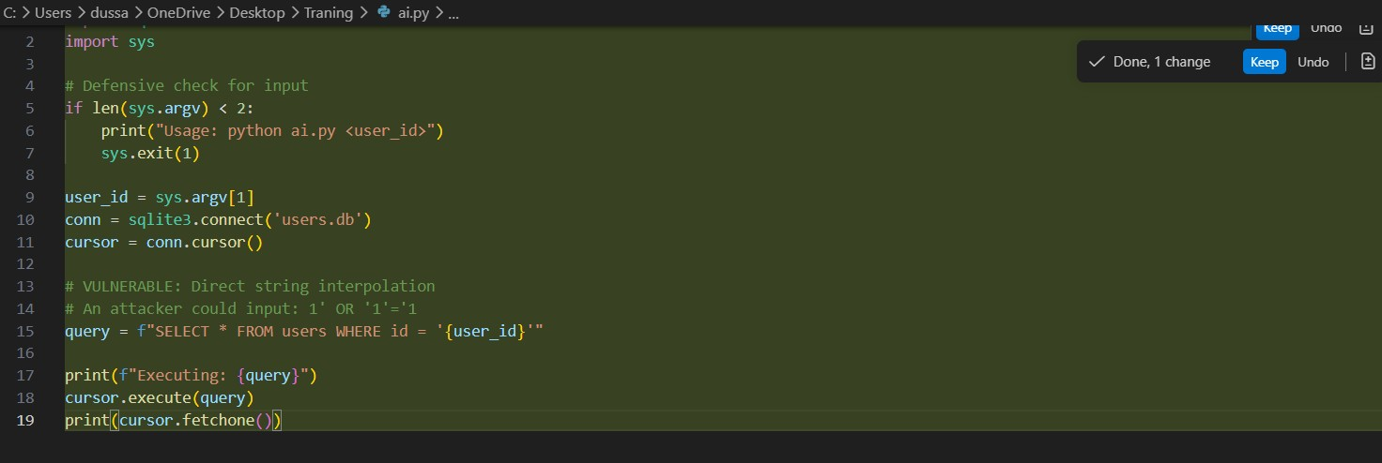
Explanation
- Vulnerability: Using f-strings or string concatenation to build database queries.
- The Risk: Attackers can bypass logins or delete tables using commands like ' OR 1=1.
- The Fix: Use Parameterized Queries (? placeholders). This treats user input as data, not as code.
- Rule: Never concatenate variables directly into SQL strings.

Task 3 – Cross-Site Scripting (XSS) Check Task:
Evaluate an AI-generated HTML form with JavaScript for XSS vulnerabilities.
Instructions:
- Ask AI to generate a feedback form with JavaScript-based output.
- Test whether untrusted inputs are directly rendered without escaping.
- Implement secure measures (e.g., escaping HTML entities, using CSP).
Expected Output:
- A secure form that prevents XSS attacks.

Prompt to AI
"Generate an HTML feedback form with JavaScript that displays the user's name on the page after they submit it."

Code:
<!DOCTYPE html>
<html lang="en">
<head>
<meta charset="UTF-8" />
<meta name="viewport" content="width=device-width, initial-scale=1.0" />
<title>Feedback Form</title>
<style> body {
font-family: Arial, sans-serif;
max-width: 500px; margin: 40px auto;
padding: 0 20px;
}
form { display: grid;
gap: 12px;
} label {
font-weight: bold;
} input, textarea { padding: 8px; font-size: 1rem; width: 100%;
box-sizing: border-box;
}
button {
padding: 10px 16px; font-size: 1rem;
cursor: pointer;
}
#message { margin-top: 20px; font-size: 1.1rem;
color: #2c3e50;
}
</style>
</head>
<body>
<h1>Feedback Form</h1>
<form id="feedbackForm">
<label for="name">Your Name</label>
<input type="text" id="name" name="name" required />

<label for="feedback">Feedback</label>
<textarea id="feedback" name="feedback" rows="4" required></textarea>

<button type="submit">Submit</button>
</form>

<div id="message"></div>

<script>
const form = document.getElementById('feedbackForm'); const message = document.getElementById('message');

form.addEventListener('submit', function (event) {
event.preventDefault();
const name = document.getElementById('name').value.trim();

if (!name) {
message.textContent = 'Please enter your name.'; return;
}

message.textContent = `Thank you, ${name}! Your feedback has been received.`; form.reset();
}); </script>
</body>
</html>

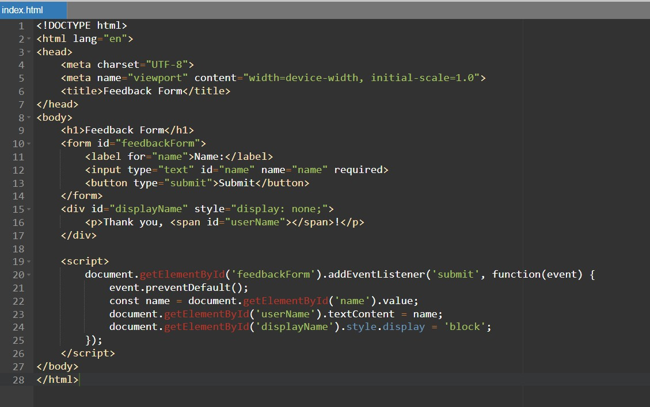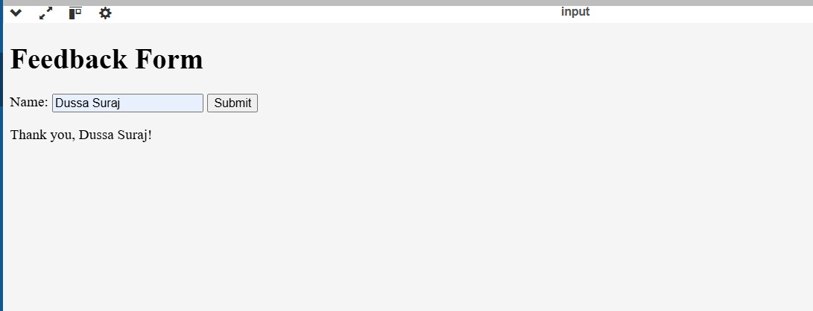
Explanation
Cross-Site Scripting (XSS) Check
Goal: Prevent malicious scripts from running in a user's browser.
- The Problem: If a website takes a user's name and displays it using .innerHTML, an attacker can set their name to <script>alert('Hacked')</script>. The browser will execute that script.
- The Fix: Output Encoding. Instead of .innerHTML, use .textContent. This tells the browser to display the characters exactly as they are written rather than trying to "run" them as HTML/JavaScript.
- Key Security Principle: "Escape All Output."

Task 4 – Real-Time Application: Security Audit of AI-Generated Code Scenario:
Students pick an AI-generated project snippet (e.g., login form, API integration, or file upload).
Instructions:
- Perform a security audit to detect possible vulnerabilities.
- Prompt AI to suggest secure coding practices to fix issues.
- Compare insecure vs secure versions side by side.
Expected Output:
- A security-audited code snippet with documented vulnerabilities and fixes.

AI Prompt
"Generate a Python Flask script that allows a user to upload a file to a folder named 'uploads'.
Then, perform a security audit on this code to identify vulnerabilities like 'Path Traversal' and
'Unrestricted File Upload'. Finally, provide a secure version of the code."

Code: import os from flask import Flask, request, send_from_directory from werkzeug.utils import secure_filename

BASE_DIR = os.path.abspath(os.path.dirname(__file__))
UPLOAD_FOLDER = os.path.join(BASE_DIR, "uploads")
ALLOWED_EXTENSIONS = {"png", "jpg", "jpeg", "gif", "txt", "pdf"}
MAX_CONTENT_LENGTH = 16 * 1024 * 1024 # 16 MB

app = Flask(__name__) app.config["UPLOAD_FOLDER"] = UPLOAD_FOLDER app.config["MAX_CONTENT_LENGTH"] = MAX_CONTENT_LENGTH

if not os.path.exists(UPLOAD_FOLDER):
os.makedirs(UPLOAD_FOLDER, exist_ok=True)

def allowed_file(filename):
return "." in filename and filename.rsplit(".", 1)[1].lower() in ALLOWED_EXTENSIONS

@app.route("/", methods=["GET"])
def index(): return """
<!doctype html>
<title>Upload File</title>
<h1>Upload file</h1>
<form method=post enctype=multipart/form-data action="/upload">
<input type=file name=file>
<input type=submit value=Upload>
</form>
"""

# Insecure version:
# - Path Traversal: user-controlled filename saved directly into the upload folder.
# - Unrestricted File Upload: no extension or size restriction. @app.route("/upload_insecure", methods=["POST"]) def upload_insecure():
if "file" not in request.files: return "No file part", 400

file = request.files["file"] if file.filename == "":
return "No selected file", 400

filename = file.filename file.save(os.path.join(app.config["UPLOAD_FOLDER"], filename)) return f"Uploaded insecurely as {filename}", 200

# Secure version:
# - Use secure_filename to sanitize the filename.
# - Enforce a whitelist of allowed extensions.
# - Enforce a maximum upload size.
# - Ensure the final destination remains inside the uploads folder.
@app.route("/upload", methods=["POST"]) def upload_secure():
if "file" not in request.files: return "No file part", 400

file = request.files["file"] if file.filename == "":
return "No selected file", 400

if not allowed_file(file.filename):
return "File type not allowed", 400

filename = secure_filename(file.filename) if filename == "":
return "Invalid filename", 400

destination = os.path.realpath(os.path.join(app.config["UPLOAD_FOLDER"], filename)) upload_root = os.path.realpath(app.config["UPLOAD_FOLDER"]) if not destination.startswith(upload_root + os.sep):
return "Invalid destination path", 400

file.save(destination) return f"File uploaded securely as {filename}", 200

@app.route("/uploads/<path:filename>") def uploaded_file(filename):
return send_from_directory(app.config["UPLOAD_FOLDER"], filename)

if __name__ == "__main__":
app.run(debug=True)

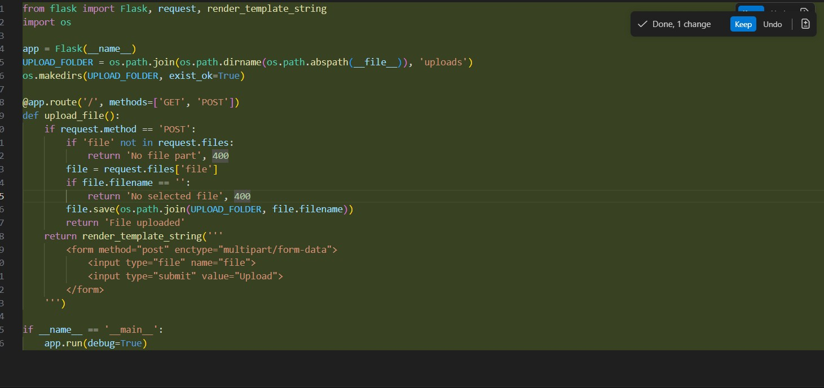

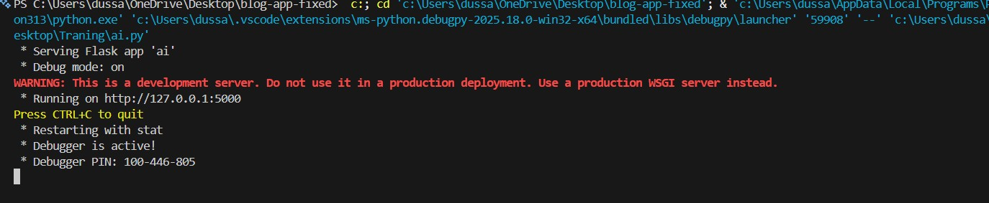
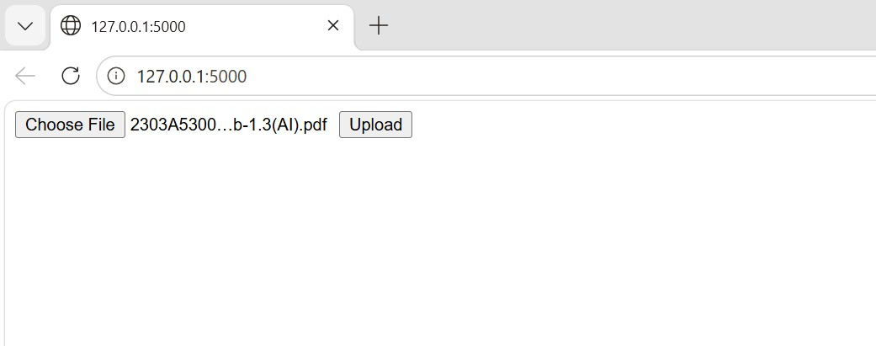
Explanation
Security Audit (File Uploads)
- Vulnerability: Trusting the original filename and allowing any file extension.
- The Risk: Remote Code Execution (RCE) via uploaded scripts and Path Traversal attacks.
- The Fix: Use secure_filename() and a strict Extension Whitelist (e.g., only .jpg, .png).
- Rule: Always rename and validate uploaded files on the server side.

Task 5 – Insecure Data Serialization Check Task:
Evaluate AI-generated code that uses pickle for saving user data.
Instructions:
- Ask AI to generate a script using pickle.load().
- Explain why untrusted pickle data is dangerous.
- Replace with safer formats like JSON. Expected Output:
- Secure serialization code using JSON instead of pickle.

AI Prompt Used
"Generate a Python script that uses pickle.dump() to save user profile data and pickle.load() to read it back. Explain why loading untrusted pickle data is a security risk (Remote Code Execution). Then, rewrite the script using the json module to make it secure."

Code:
import json import pickle
from pathlib import Path

def save_profile_pickle(profile: dict, path: Path) -> None:
path.parent.mkdir(parents=True, exist_ok=True) with path.open("wb") as handle: pickle.dump(profile, handle)

def load_profile_pickle(path: Path) -> dict: with path.open("rb") as handle: return pickle.load(handle)

def save_profile_json(profile: dict, path: Path) -> None:
path.parent.mkdir(parents=True, exist_ok=True) with path.open("w", encoding="utf-8") as handle:
json.dump(profile, handle, indent=2)

def load_profile_json(path: Path) -> dict:
with path.open("r", encoding="utf-8") as handle:
return json.load(handle)

def main() -> None:
profile = {
"username": "jdoe",
"email": "jdoe@example.com",
"preferences": {"theme": "dark", "notifications": True},
"login_count": 42,
}

pickle_path = Path("profiles/user_profile.pkl") json_path = Path("profiles/user_profile.json") save_profile_pickle(profile, pickle_path)
save_profile_json(profile, json_path)

loaded_pickle = load_profile_pickle(pickle_path) loaded_json = load_profile_json(json_path)

print("Pickle loaded:", loaded_pickle)
print("JSON loaded:", loaded_json)

if __name__ == "__main__":
main()

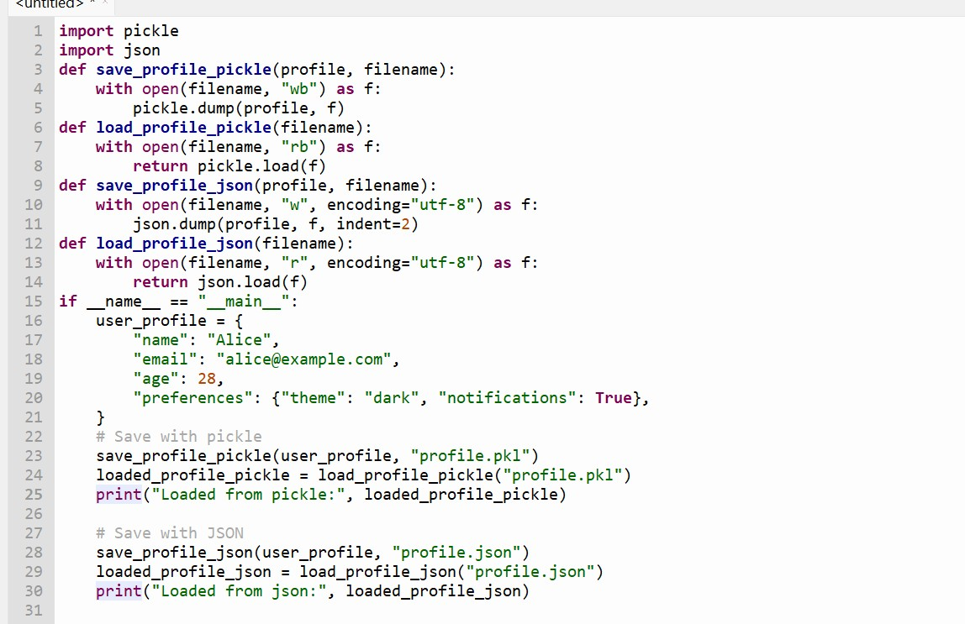

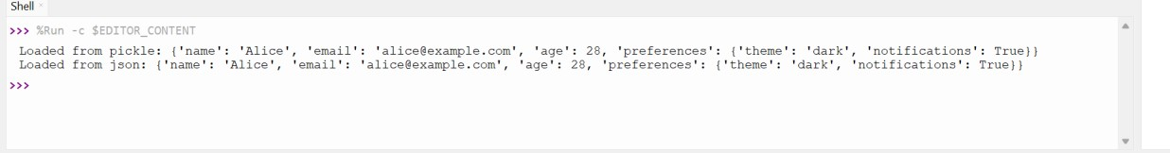
Explanation
Insecure Serialization
- Vulnerability: Using the pickle module to save/load user-controlled data.
- The Risk: pickle.load() can execute arbitrary system commands, leading to a full system compromise.
- The Fix: Replace pickle with JSON. JSON is a data-only format and cannot execute logic.
- Rule: Avoid pickle for any data that crosses a trust boundary.

